Documentation

CSCI_6461_12: Project P3

Group 10:

Alekya Kowta

Nikhil Arethiya

Peiyan Liu

Aryan Saxena

Overview and Purpose

Part III extends the Part II simulator with a TRAP code implementation, and the ability to run Program 2 (read a paragraph, input a search word, find and print the occurrence of the word). We also expanded the UI to show compact output of the word in proper format.

GitHub Repository Link
https://github.com/AlekyaKowta/CSCI_6461_FALL25_PROJECT-TEAM-10

Installation and Usage
Installation:
- Ensure the target system has Java Runtime Environment (JRE) version 8 or higher installed.
- Download the packaged folder (typically named dist_p3/), which contains:
  - csci6461_p3.jar (the simulator)
  - files/ directory (contains program.txt, paragraph.txt, test files, etc.)
- Keep the JAR and the files folder in the same directory, as the simulator loads Program 2 data from files/program.txt or files/paragraph.txt.
- Place your Program 2 machine code file (e.g., LOADFILE.txt) in the same directory as the JAR.
Usage:
- Open a terminal or command prompt.
- Navigate to the directory containing the JAR (dist_p3)
- Run the assembler with the command:
java -jar csci6461_p3.jar
- Load Program: Click the IPL button and select your load file provided.
- Execute: Use Step for instruction-by-instruction execution or Run to execute continuously.
- Click on Run
- The program currently uses a program.txt file which has the following content:
Rain falls gently against the window. A gentle rain often brings peace, yet sometimes it hides a storm. The children watch the rain as it gathers into puddles that reflect the sky.
- When asked to input a word, you can enter “window”
- Once the program HLTs in the Printer area, click on “Refresh Output” near the Compact Output Channel
- You will see the word occurrence
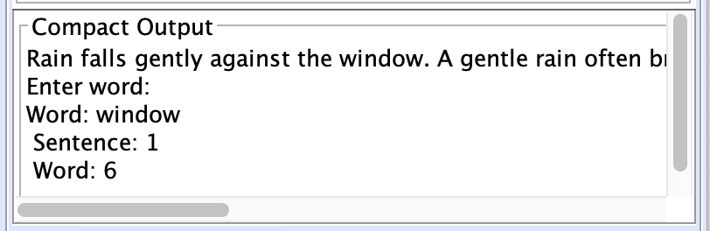

- If you enter a word that is not present, this will be the output:
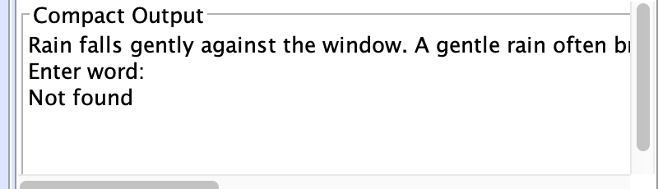
- Observe results in the Printer, Compact Output area on the right panel.

Testing With Other Paragraphs or Scenarios
To test additional inputs:
- Open the files/paragraph.txt file in any text editor.
- Replace the existing paragraph text with your own.
- Save the file.
- Run the simulator again (no rebuild required).
The simulator will use whatever text is present in the files/program.txt file at runtime.

Folders
Folder Contents:
- Documentation/ -> Consists of all the Documentation Notes
- Files/ -> Consists of all the test files and asm files
- Src.main.java ->
  - Core ->
Consists of Machine Controller, Machine State
    - Cache -> Contains the cache specifics
  - Assembler -> Contains Assembler.java and OpcodeTables.java
  - Ui -> Contains SimulatorUI.java
  - Paragraph -> Contains some java files to test P2

User Interface
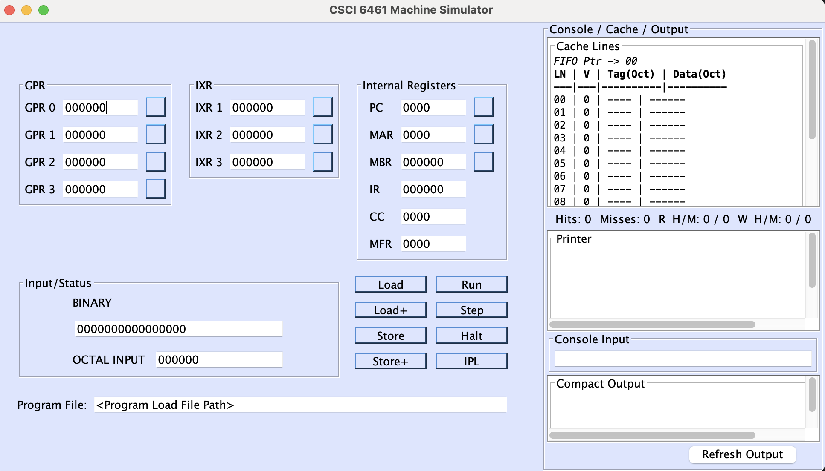

The simulator’s Swing-based front panel provides complete visibility of machine registers, memory, and cache state.

Register Display
- GPR0–GPR3, IX1–IX3: 16-bit registers displayed as 6-digit octal values.
- PC, MAR: 12-bit registers displayed as 4-digit octal values.
- CC, MFR: 4-bit registers displayed as 4-digit octal values.

Cache Panel
- Displays 16 cache lines (fully associative) in a monospaced grid.
- Recent access is highlighted: green for hit, red for miss.
- FIFO pointer and detailed hit/miss statistics displayed below.

Printer Area
- Displays all the debug output

Compact Output
- Displays the word, sentence occurrence as a readable result.

Input Specification
The simulator accepts a machine code load file generated by the assembler.
The simulator requires a Load File as input, which is the direct numerical output from the two-pass assembler. This file defines the memory addresses and their contents.
During runtime, the user inputs a word to search and if it finds it, it will display that

Output Specification
Content | Format | Description
Paragraph Display | Text | Shows the full paragraph loaded from the input file before processing begins.
Input Prompt | Text | Displays the request: “Enter word:” and waits for user input through TRAP input routine.
Search Echo | Text | Prints “Word: <user_input>” confirming the word entered.
Sentence Number | Text | Prints the sentence index (starting at 1) where the word is found. Format: “Sentence: ”.
Word Number | Text | Shows the position of the word within that sentence (1-indexed). Format: “Word: ”.
No-Match Indicator | Text | If the word is not present in any sentence, prints: “Not found”.
Execution Output (Compact Output Panel) | Console-like text | Displays only characters printed via OUT/TRAP 1 (the readable result of the program).
Printer Log | Text Area | Logs each OUT instruction in the form: -> OUT Printer: '<char>' for debugging.
Trace Log | Text/Display | (Optional, if enabled) Shows TRAP, LDA, LDR, comparisons, and branching activity relevant to Program 2.
Fault Log | Text | Reports invalid memory references, bad opcodes, or TRAP misuse during search.
Halt Status | Text | Indicates successful completion with a newline and HLT execution.

Design and Structure

Key Architectural Components
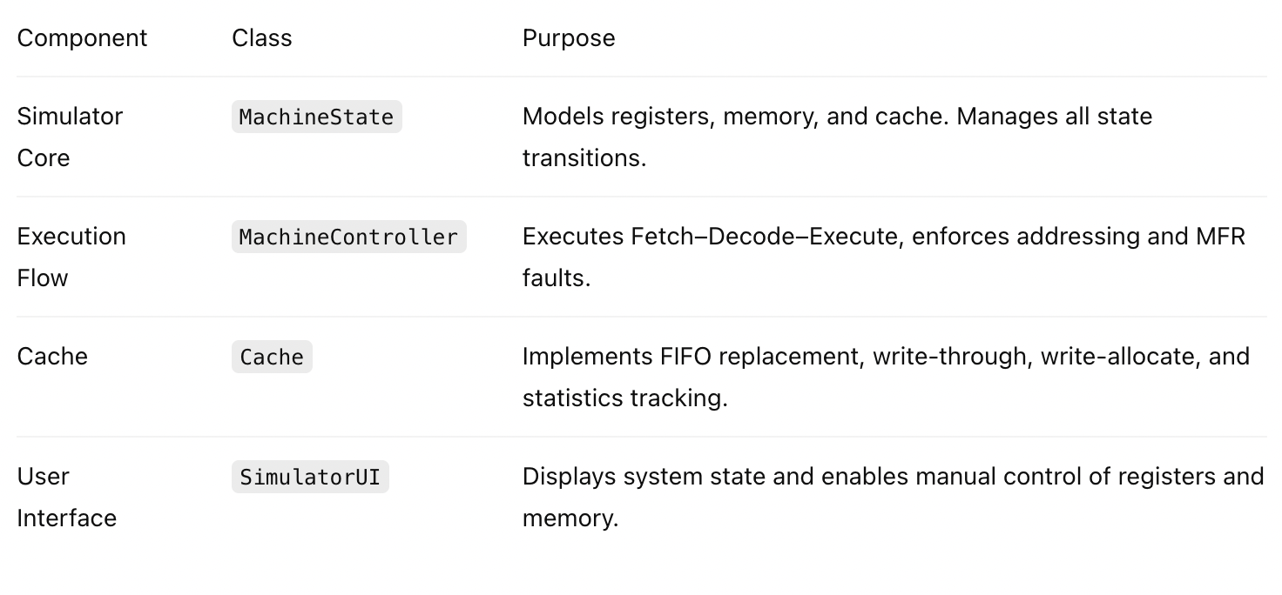

Execution Controls

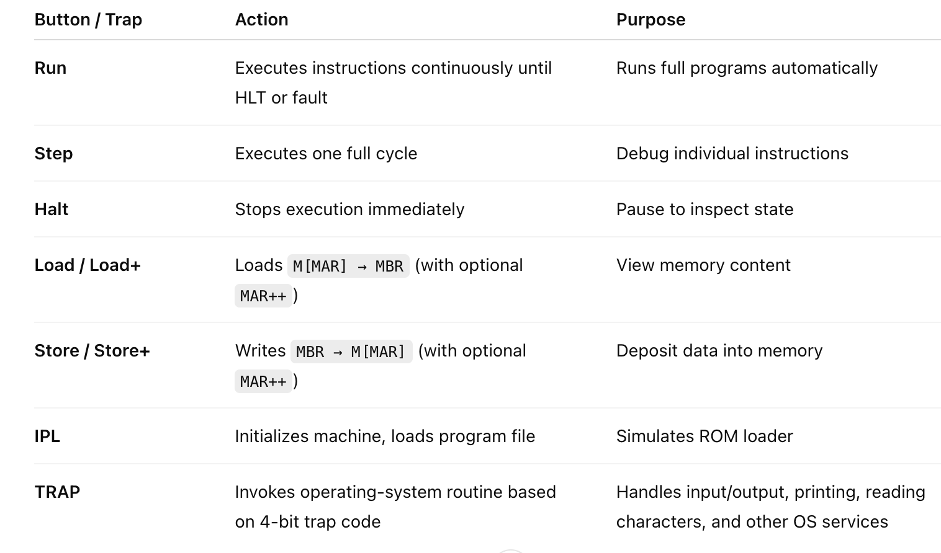

Error Handling
- Illegal Opcode: Sets MFR and halts.
- Address Out of Range: Guarded in EA computation; halts with MFR flag.
- Undefined Device: Logs warning in printer area.
- IPL Errors: Displayed clearly with no state modification.

Extensibility
- Modular instruction handlers allow new operations without major refactoring.
- Cache system easily configurable for LRU or write-back in future phases.
- UI expandable for floating-point/vector extensions in Part IV.

Limitations
- Floating Point, and Vector instructions unimplemented (reserved for Part IV).
- Condition Code updates simplified for certain arithmetic operations.
- No true asynchronous I/O or interrupt handling.

Testing
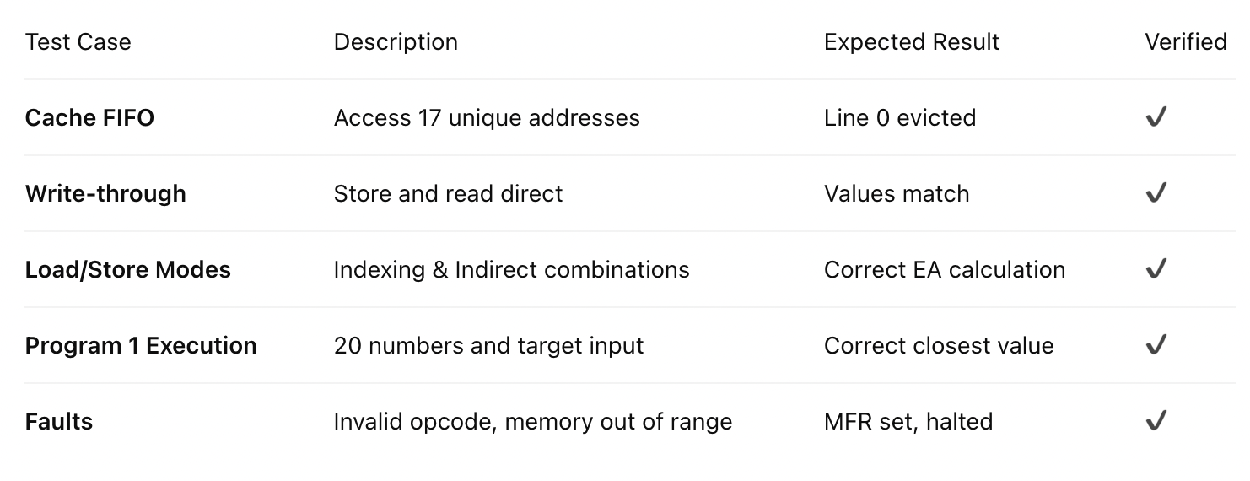

Test Cases for Program 2:

Test Case 1

The sun rises slowly, painting the horizon with gold. Birds flutter across the quiet fields, carrying whispers of dawn. Suddenly, thunder echoes beyond the hills—yet the morning stays calm. Gold clouds gather, drifting lazily toward the east.
Word: Birds
Output:
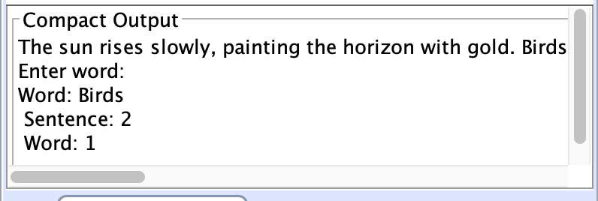

Test Case 2

Time moves. People change. Stories begin and end. Moments fade, but memories remain.
Word: begin and end
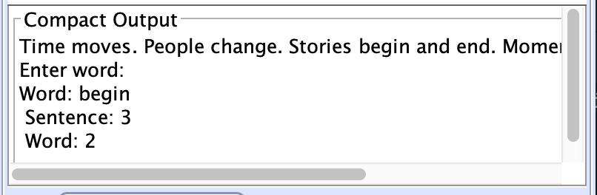

Test Case 3

Hope rises in the darkest nights. In those nights, courage grows quietly. Nights filled with silence often carry the brightest dreams.
Word: in
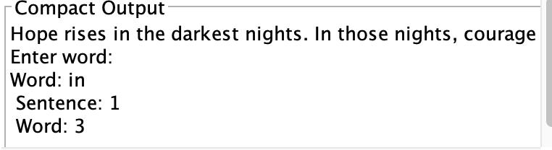

Test Case 4
Inside the cathedral, voices echo. The echo travels through arches, corridors, and stone halls. Although the echo fades, its presence lingers like a quiet reminder.
Word: echo
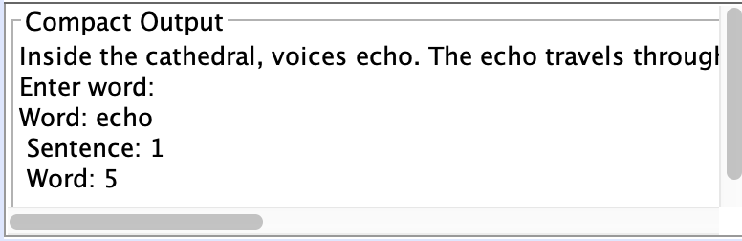

Test Case 5
Inside the cathedral, voices echo. The echo travels through arches, corridors, and stone halls. Although the echo fades, its presence lingers like a quiet reminder.
Word: ec
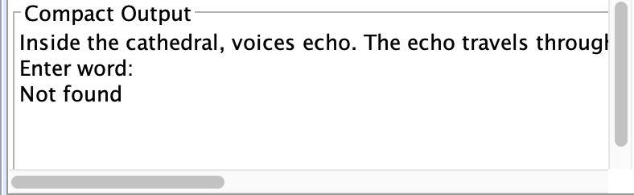

Test Case 6
Beyond the valley lies a forgotten village, wrapped in mist. Travelers rarely pass through, though legends claim the village awakens at dusk. Lanterns glow softly, bells chime faintly, and shadows dance across ancient stone bridges. Some say the air itself remembers.
Word: air
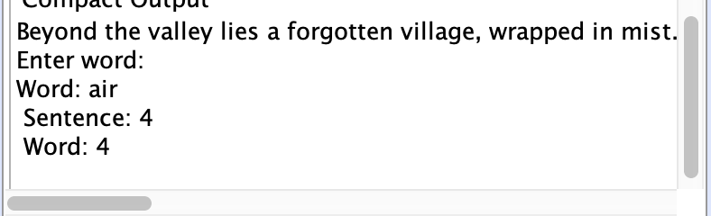

References
- Instruction Set Architecture Specification Document
- Java Development Kit Documentation
- Related Academic Publications on Assembly Language Programming

